**Ideation Phase**

**Define the Problem Statements**

|  |  |
| --- | --- |
| Date | 31 January 2025 |
| Team ID | LTVIP2025TMID34696 |
| Project Name | Enchanted Wings: Marvels Of Butterfly Species |
| Maximum Marks | 2 Marks |

**Customer Problem Statement Template:**

Create a problem statement to understand your customer's point of view. The Customer Problem Statement template helps you focus on what matters to create experiences people will love.

A well-articulated customer problem statement allows you and your team to find the ideal solution for the challenges your customers face. Throughout the process, you’ll also be able to empathize with your customers, which helps you better understand how they perceive your product or service.

Reference: <https://miro.com/templates/customer-problem-statement/>

**Example :**

I am I am trying to But Because which makes me feel

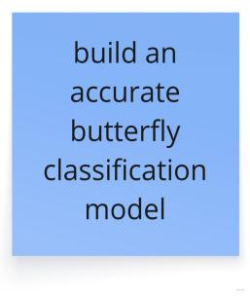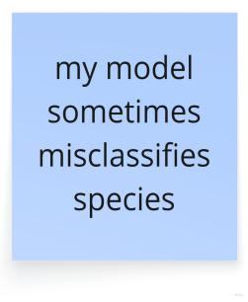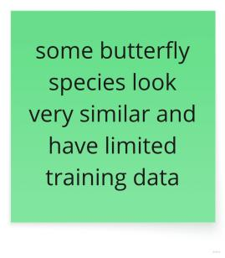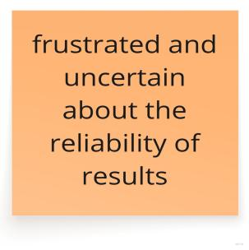

|  |  |  |  |  |  |
| --- | --- | --- | --- | --- | --- |
| **Problem Statement (PS)** | **I am (Customer)** | **I’m trying to** | **But** | **Because** | **Which makes me feel** |
| PS-1 | A biology student | Identify butterfly species from photos for my project | I don’t know if my answers are correct and it takes a lot of time | Many species look similar and no clear tool tells me the exact species | Confused, doubtful, and frustrated |
| PS-2 | A wildlife conservationist | Track and record butterfly species in a specific region | Manual tracking is slow and not possible for many images | There are too many images and too few experts to verify them | Overwhelmed and worried about missing data |